September is National Preparedness Month
“Be Ready, Not Scared”
Preparedness
- Build a Basic Emergency Supply Kit  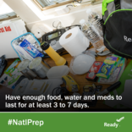  Click Here to Learn More | - Make a Family Communication Plan  “Let them know you’re OK!”  Click Here to Learn More
Situational Awareness—On the Go
- Be Prepared—GetReadyTN  Information on road conditions, weather updates,  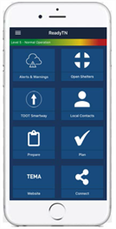  open shelters , contacts for county emergency  management agencies and more.  Click Here to Learn More | - FEMA  National Weather Service real-time alerts,  emergency safety tips, locate open emergency  shelters and disaster recovery centers, share  alerts via text, email and social media  Click Here to Learn More
Recovery
- Coping with a Disaster or Traumatic Event  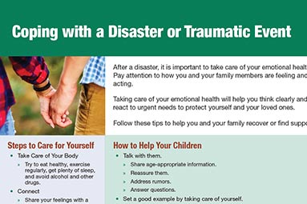  Click Here to Learn More | - Helping Children Cope After a Disaster  Click Here to Learn More

